Name the fish game UK sea waters
Use the pictures and Latin names to help you identify the fish which can be found while scuba diving in UK waters. Have Fun

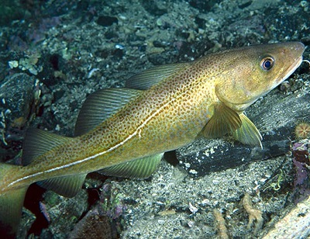
Gadus Morhua Atlantic Cod

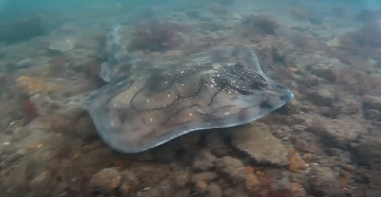
Raja Undulata Undulate ray

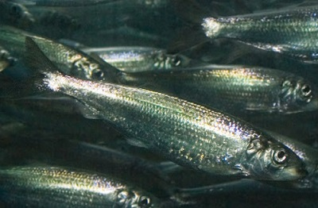
Clupea Harengus Atlantic Herring

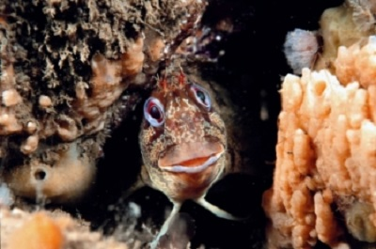
Parablenius Gattorugine Tompot Blenny

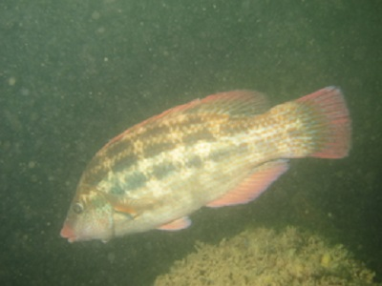
Symphodus Bailloni Baillon Wrasse

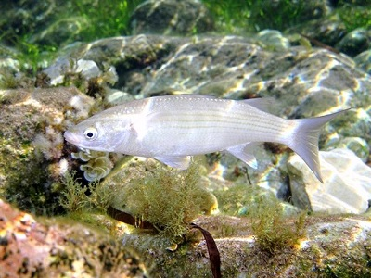
Chelon Labrosus Grey Mullet

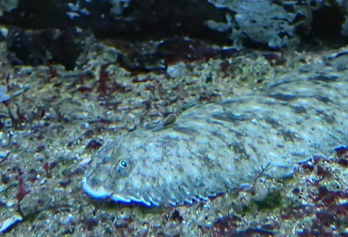
Solea Solea Dover Sole

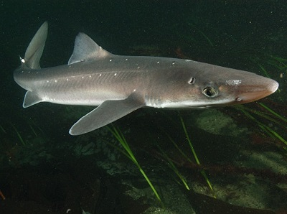
Squalus acanthias Spiny dogfish

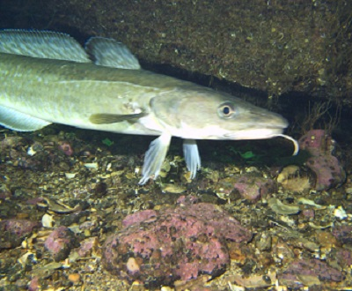
Molva Molva Ling

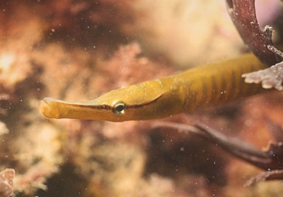
Entelurus Aequoreus Snake Pipefish

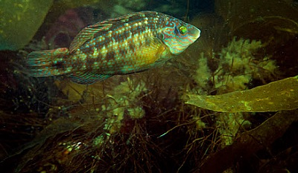
Symphodus Melops Corkwing wrasse

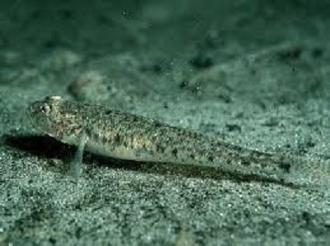
Pomatoschistus Minutus Sand Goby

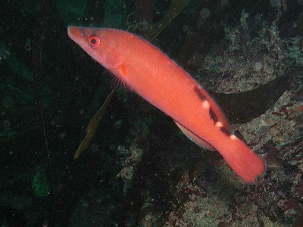
Labrus Mixtus Cuckoo Wrasee

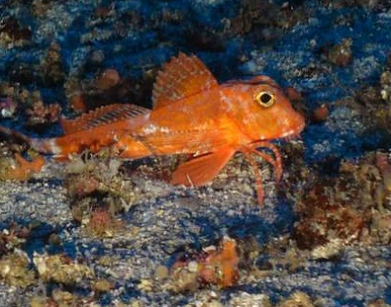
Cheilonichthys minutus Red Gurnard

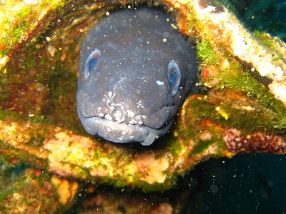
Conger Conger European Conger Eel
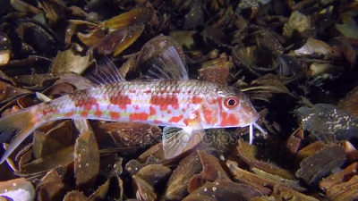
Mullus Barbatus Red Mullet

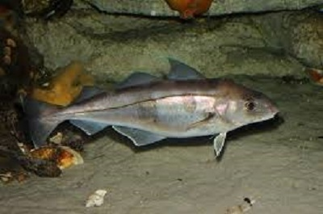
Melanogrammus aeglefinus Haddock

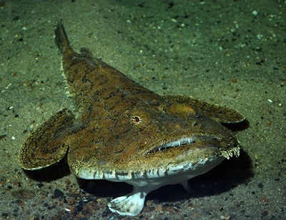
Lophius Piscatorius Monkfish

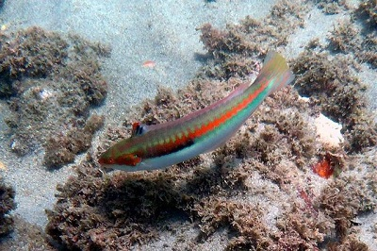
Coris julis Rainbow Wrasee

